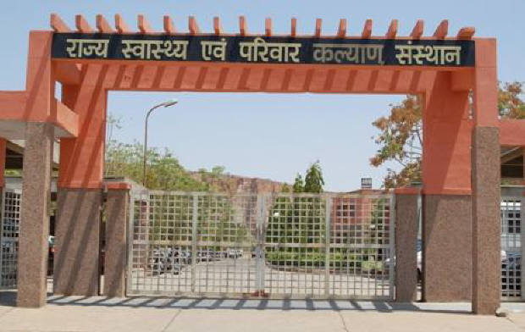
SIHFW Rajasthan

Electronic Newsletter
September Issue 2023 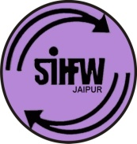
SIHFW: an ISO 9001:2015 certified Institution
From the Director’s desk…

Dear Friends…

Greetings from SIHFW!!

This year, we celebrated 76th Independence Day on 15th August, 2023. SIHFW family gathered together for flag hoisting and a cultural get-together. SIHFW staff was motivated by faculties and senior personnel to remain dedicated and focused towards goals, which is the ultimate patriotism for every citizen.
We would solicit your feedback and suggestions.

Best Wishes!!
Dr. O.P. Thakan
Director-SIHFW
_____________________________________________________________
Some important health and social days for April to September 2023
7-April World Health Day | 1 July Doctors’ Day
11-April World Parkinsons Day | 11-July World Population Day
22-April Earth Day | 1-7 August World Breastfeeding Week
5 May World Asthma Day | 12 August World Organ Donation Day
8-May World Red Cross Day | 8 September –World First Aid Day
12 May International Nurses Day | 10 September-World Suicide Prevention Day
19 May Worls Hepatitis Day | 21 September –World Alzheimer’s Day
31-May Anti-Tobacco Day. | 28 September-World Rabies Day
5-June World Environment Day | 29 September-World Heart Day
11- June World Blood Donor Day | 30 September- World Deaf Day

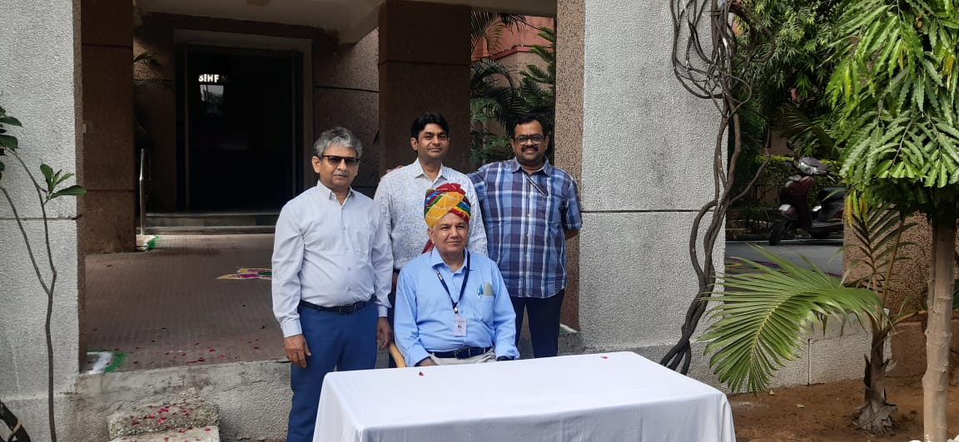
Independence Day, August 15th, 2023

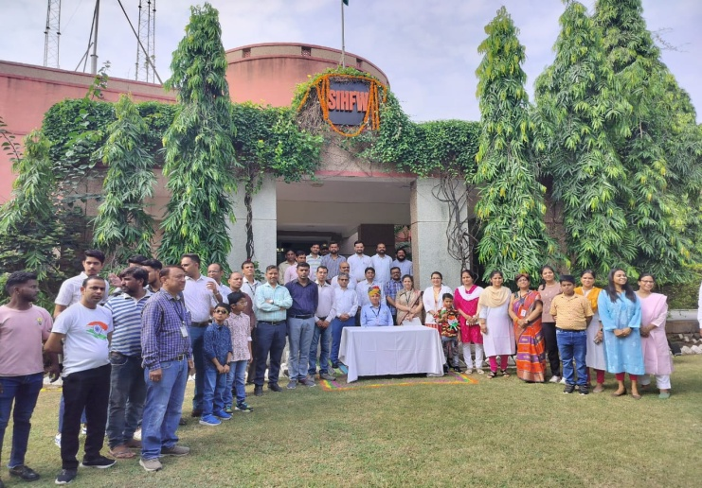

On occasion of Independence day, Dr Sunita Thakan, Faculty, Gyne from SIHFW was awarded certificate of Appreciation and Recognition of good works. This was a moment of celebration for all SIFW staff, since it was very inspiring for all.

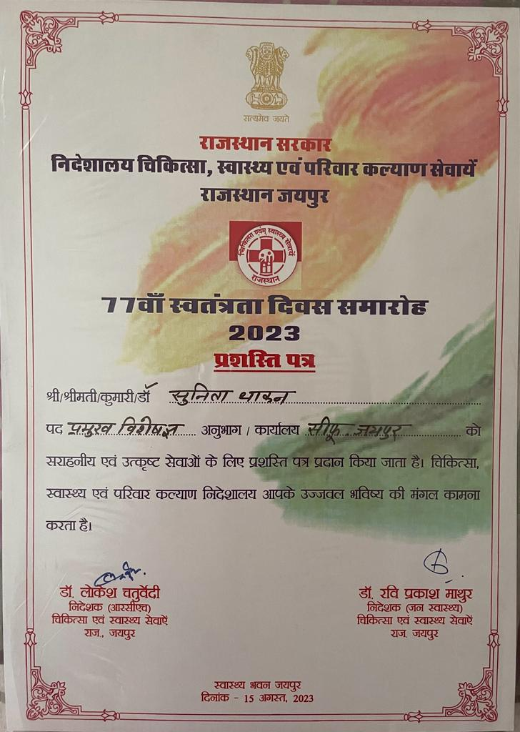
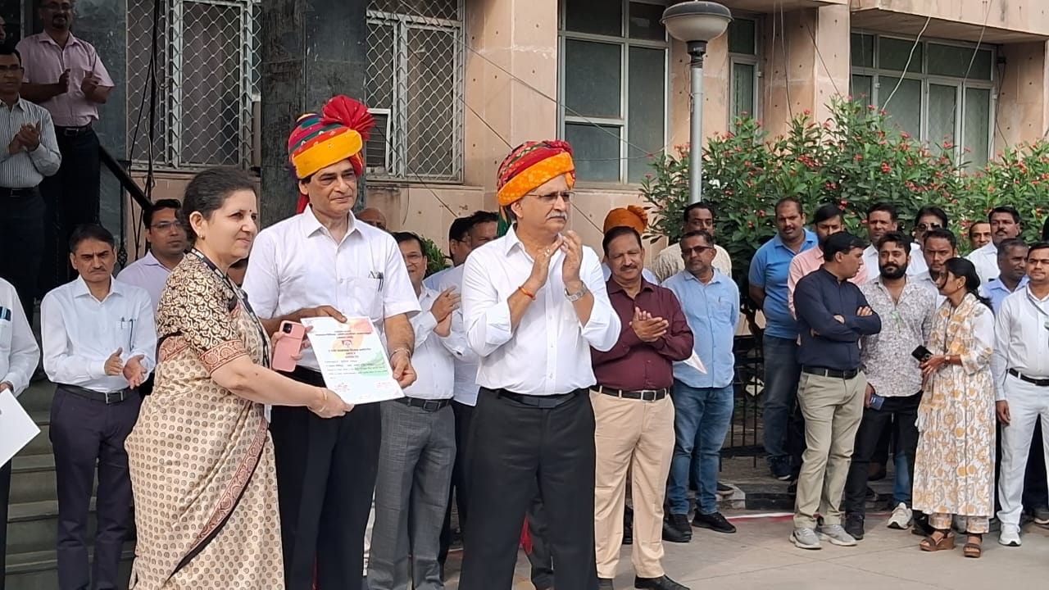

Pledge for Organ Donation
On occasion of World Organ Donation Day on August 12, Director SIHFW, All faculties and SIHFW staff took pledge for organ donation.
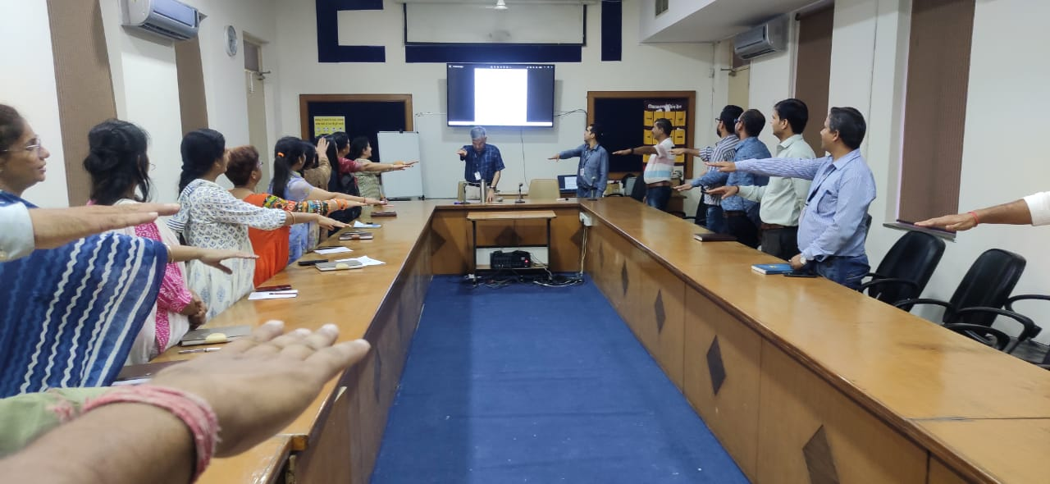

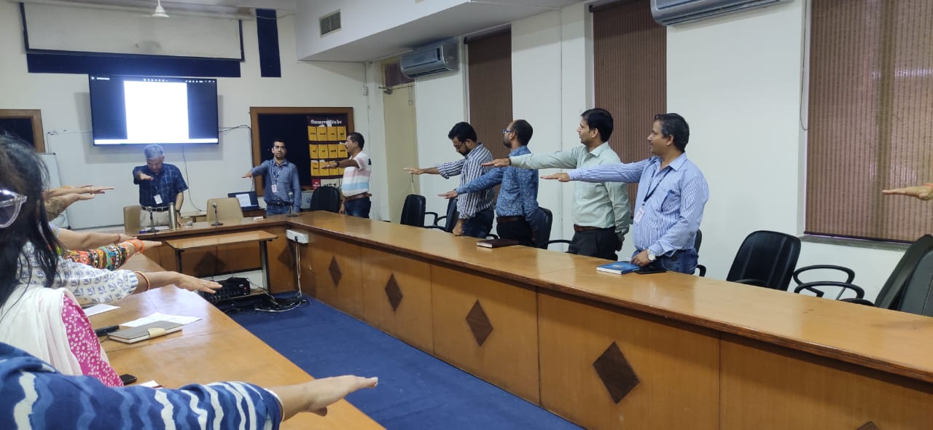

VC for Training Review at SIHFW

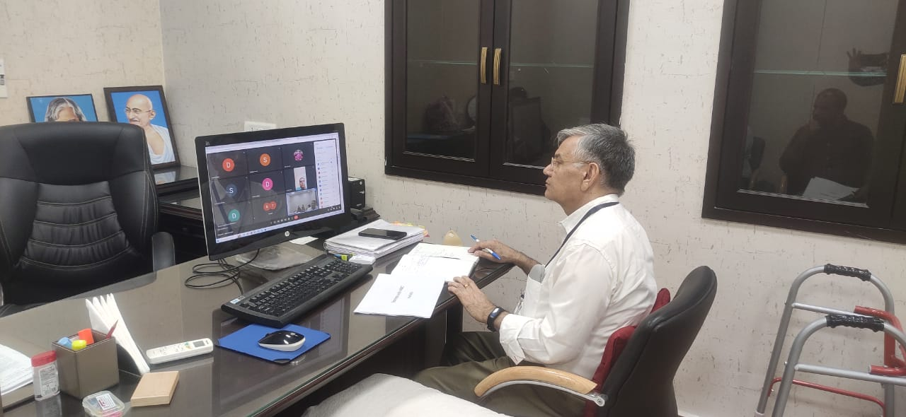
Online Video review meeting was organised under chairmanship of Director SIHFW on August 18, 2023. It was organised through google meet to review training progress under HWC trainings. Participants were CMHOs, Dy CMHOs (Health) and DPMU staff from selected districts where training progress is slower as compared to other districts.

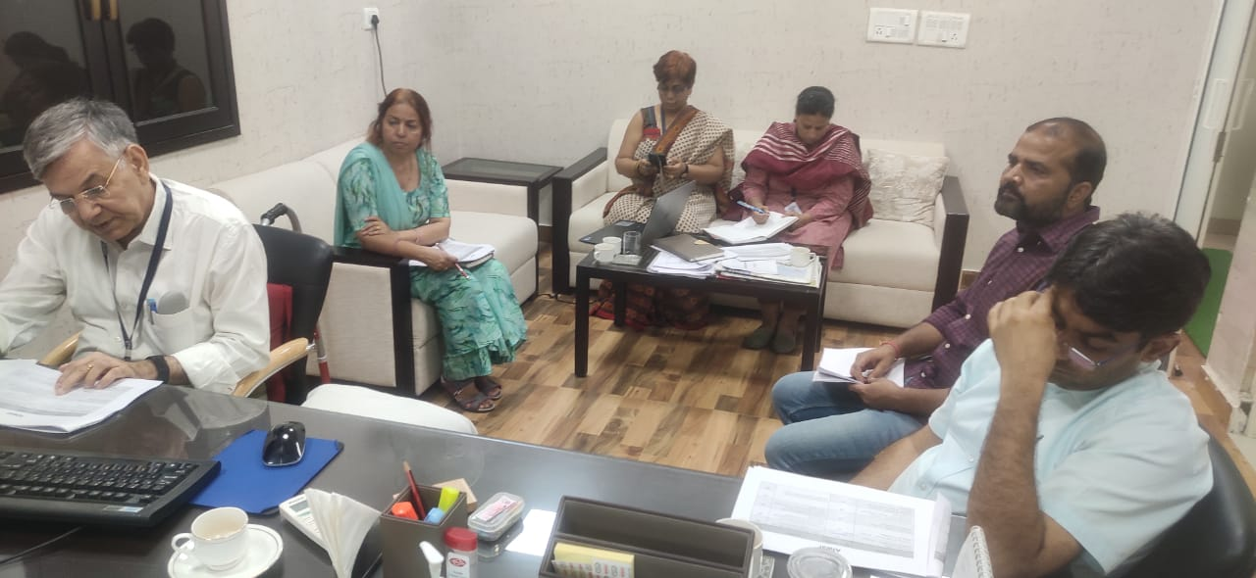
Through an online presentation, all districts were briefed about set of HWC trainings sanctioned in each district for various cadres-Medical Officer, CHO, Staff Nurse, ANM and ASHA. Physical and financial progress of HWC trainings was discussed with each district.

Workshops at SIHFW
Integrated Public Health Lab (IPHL)

A one day orientation workshop cum meeting was organised by IDSP cell at SIHFW on July 31, 2023. It was focussed on implementation of Integrated Public Health Lab.

Basic Occupational Health Services-Basic Course was organised on June 26 and 27, 2023 in coordination with Silicosis Research Board, SMS Medical College.

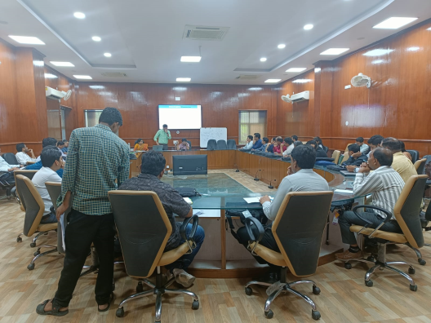
Dakshta-Cross learning workshop

One batch of 2 days Dakshta Cross Learning workshop was organised at SIHFW on September 26-27, 2023. District Program Managers and Dakshta Mentors participated at this workshop.

Workshop on Maternal Death Surveillance and Response (MDSR)
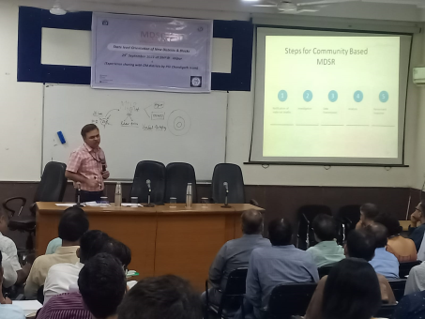
One day MDSR workshop was organised at SIHFW on September 29, 2023. Various CMHOs, BCMOs, RCHOs of newly formed districts participated at this workshop. This was a State level Orientation of New Districts and Blocks. Master trainers and knowledge support was done by PGI Chandigarh team.
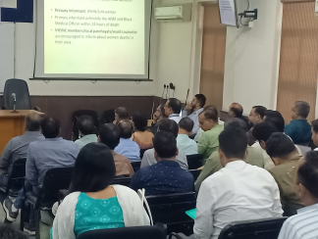

Trainings at SIHFW
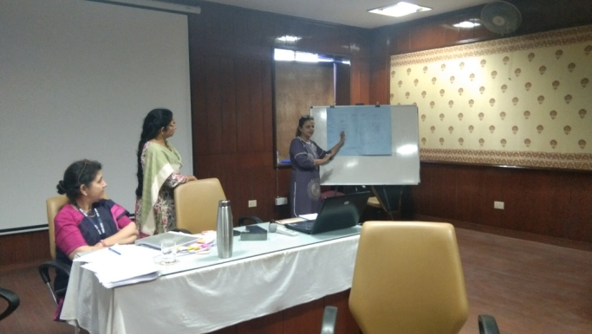
Training of Trainers (ToT)
ToT on New Contraceptives
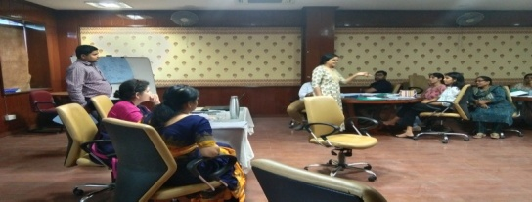
A two day ToT on new contraceptives was organised on August 24-25, 2023 at SIHFW. This was a skill based training based on basket of choices and counseling skills for Family Planning. Participants were given mock topics and they made presentation on topics. The presentations were evaluated and feedback was also provided to participants. Medical Officers and Nursing Officers participated at this training.
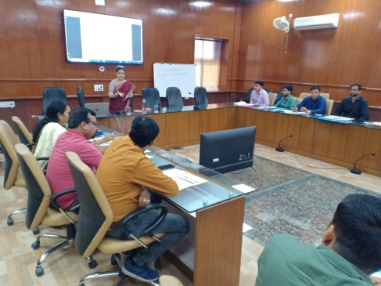
ToT on Pregnancy Weight Gain and Nutrition Counselling
Two batches of one day ToT on Enhanced nutrition counseling for pregnant and lactating mothers were organised at SIHFW on July 14 and August 8, 2023. Participants are PHN and Nursing tutors.
Total 54 Trainers have been developed in these trainings to give further training to ANMs across all districts of Rajasthan. These trainings were organised in partnership with IPE Global, Rajasthan.
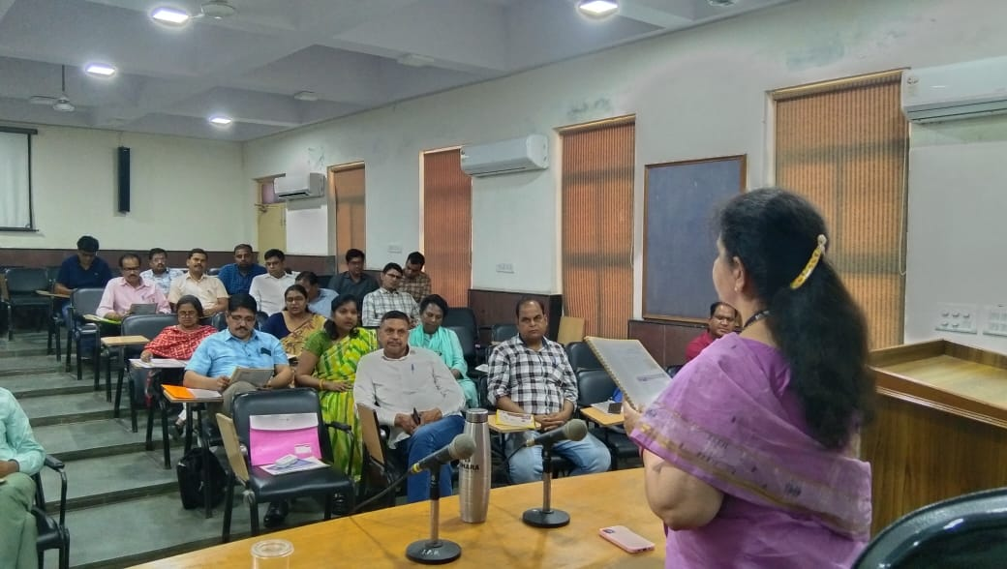
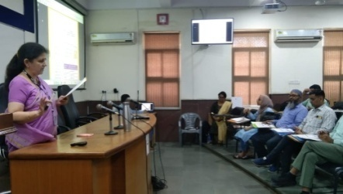

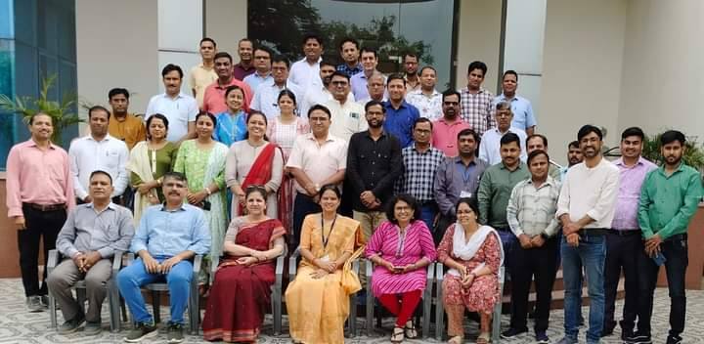
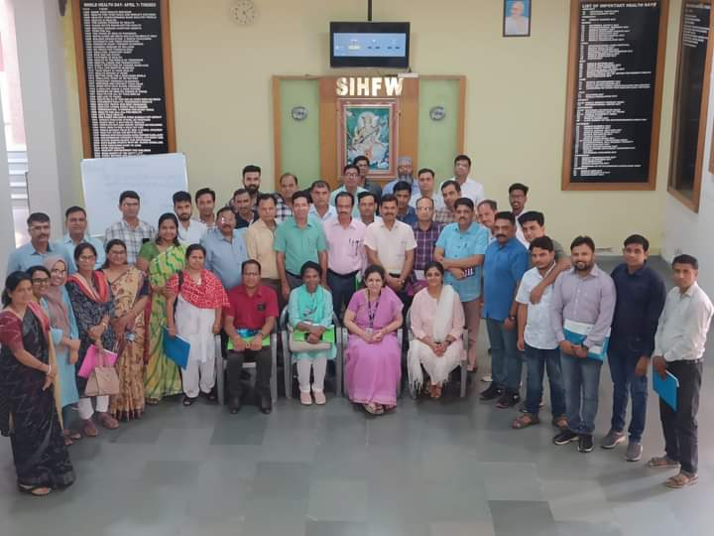

ASHA ToT –Online and Offline
During June 5 to 21, 2023, ASHA ToT batch was organized by SIHFW. This is a hybrid training of 15 days in which participants are trained in 8 days online course and 7 days offline hands-on training is organized at SIHFW. 23 participants including BHS, PHS, NT, ANM, GNM etc were trained in this training. Participants have to qualify passing marks in 3 assessments –Mock session, Skill test and written paper. Only after passing these assessments, participants become trainers for giving training to ASHA on Induction Training, Module 6&7 all 4 rounds at Districts ASHA. National level Master trainers are trainers in this training.

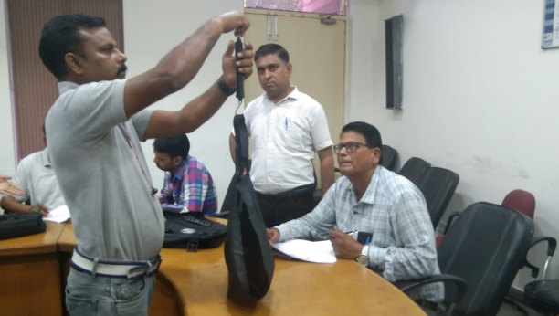
Refresher ASHA ToT
This is a 6 days training organised for previous trained ASHA trainers to revise their knowledge and skills and update with latest guidelines for ASHA trainings. This is organised at SIHFW and 6 batches have been organised by SIHFW. This includes OSCI assessments of all key skills performed by ASHA –Hand washing, Pregnancy testing, ORS, Temperature of baby, weighing of baby, wrapping of baby. Master trainers first give demonstration and participants do hands on practice in this training.
ToT SBA
One batch of two days ToT SBA was organised at SIHFW on 26-27 June, 2023. Specialists, Medical Officers, PHN and Nursing tutors participated in this training. After this ToT, trained participants will become trainers for SBA training at District level.
ToT Comprehensive Care (CAC)
This is a 3 days ToT organised by SIHFW at Medical College level. 2 batches have been organised. Participants are Gynecologists. Participants of this ToT become CAC trainers at Medical college and DH levels.
ToT Participatory Learning in Action (PLA)
This training is organised at SIHFW in coordination with Development organizations IPE Global and Ekjut. This is a 3 days ToT and 7 batches of this ToT have been organised till August, 2023.
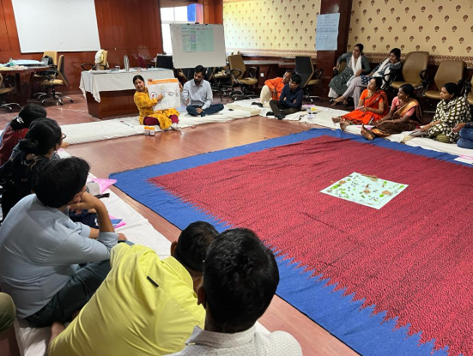
Sitting arrangement for this training is done on floor with dari and mattresses because this training has relevance with village level field work. Participants of this training will work with staff and community for developing village social maps of available resources and develop village plans with community involvement.

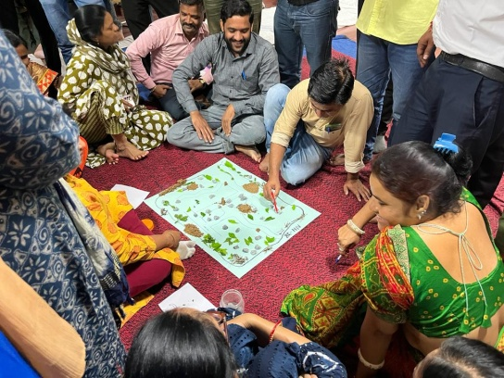

ToT Dakshta
This is a 5 days ToT organised at SIHFW. One batch of this training was organised at SIHFW on June 5 to 9, 2023. Nursing officers and Nursing Tutors are participants in this training and after training participants become Dakshta trainers.
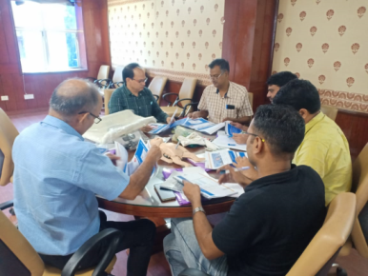
Navjat Shishu Suraksha Karyakram (NSSK) ToT
This is a 2 days ToT organised at SIHFW. One batch was organised at SIHFW on 26-27 September, 2023. Specialists-Pediatricians participate in this ToT. After this ToT participants become trainers for NSSK training at District level.
Other trainings at SIHFW
Training of Strengthening Infection Prevention and Control (IPC)
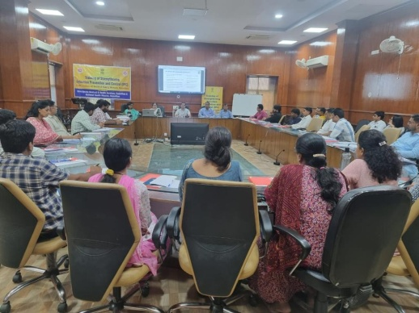
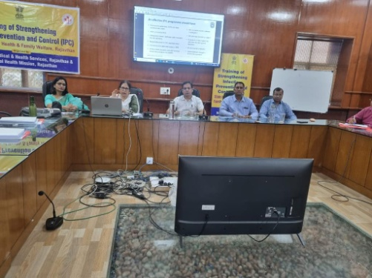
This is a 2 days training organised for Medical officers and Nursing Officers. 6 batches have been organised at SIHFW.

Training of MOs on Palliative Care
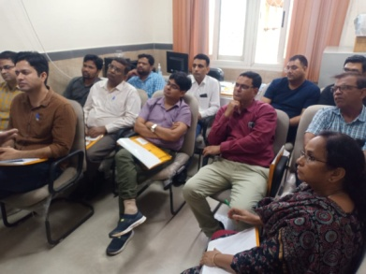
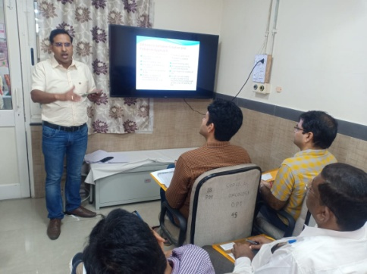
This training is organised for Medical Officers under National Prorgam for Palliative Care (NPPC) by SIHFW at SMS Medical College and Hospital, Jaipur for 3 days.

Quality Assurance Training
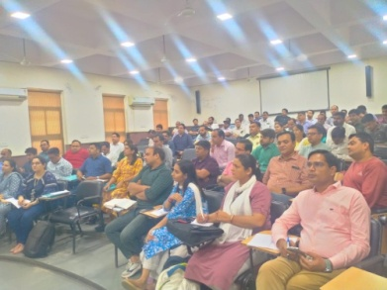
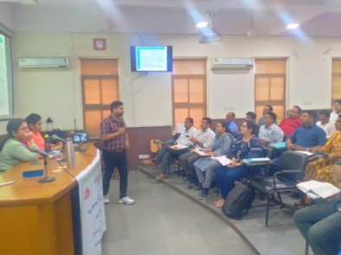
Service Provider cum Internal Assessor Training was organised at SIHFW on June 26-28, 2023 by State Quality Cell, NHM. This is a 3 days training and NQAS Assessors participated at this training.

Training on Dengue, Malaria
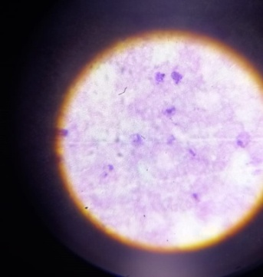
Training batches on Dengue and Malaria are organized for Medical Officers at SIHFW. This is a 2 days training. 4 batches were organized at SIHFW for Medical Officers.
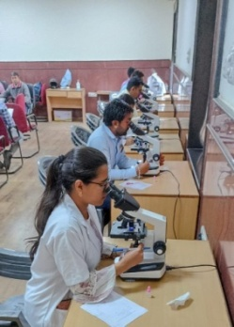
Laboratory Technicians training
With objective of imparting knowledge about Malaria under NVBDCP, laboratory technicians/Laboratory Assistants are trained at SIHFW in 5 days training. Make shift Laboratory equipped with microscopes is established in a training hall at SIHFW for this type of training. Participants are trained by Nodal Officer, Malaria programme (NVBDCP) and senior Laboratory technicians/ Lab assistants on appropriate sampling and diagnosis of Malaria. This is a hands-on skill development training. 6 batches have been organised at SIHFW for Laboratory Technicians.
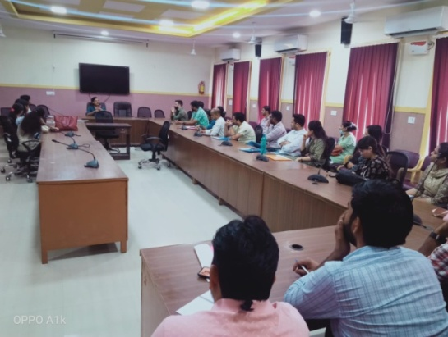
Training on Mental Health
This is a five day training of Medical Officers focused on Suicide Prevention and management. 7 batches have been organised by SIHFW and Medical Officers are trained in these training batches. Participants are taken for a visit to Psychiatric centre, Raja park, Jaipur and they are provided case studies which are discussed and analysed through discussions.
RMNCH/Family Planning Counselors training

This is a one day training organised at SIHFW on August 1, 2023.

Medical Officers Training on Routine Immunization
15 batches of this 3 days training have been organised at SIHFW. Medical officers are trained on Routine Immunization. Immunization schedule, AEFI, Cold chain, Vaccine Management etc are the components of this trianing. Participants are provided exposure visit to Immunization session sites nearby Jaipur.
Refresher ASHA Facilitators training
Refresher ASHA Facilitators training of 2 days is organised at SIHFW. BHS, PHS are participants in this training where participants are re-oriented about ASHA programme, software updates and guidelines. ASHA ToT trainers are Resource Persons in this training. 7 batches have been organized in this training.
Field Trainings
CAC training

This is a 12 days training organised at Disrtict level, where selected centres have been developed for this training. This is a clinical training and 15 batches have been organised by SIHFW.

SBA training and SBA Refresher Training

Nursing staff are provided SBA training of 21 days at District Hospitals. Participants are given classroom learning and hands-on learning at labour rooms and ANC wards at District Hospitals. Trained SBA participants are also provided a refresher training of 3 days after completing 3 years of SBA training. 5 batches of SBA training and 1 batch of 6 days Refresher have been organised by SIHFW.

Medical Method of Abortion (MMA) Training

This is a clinical training organised at District Hospitals for Medical Officers. 4 batches have been organised by SIHFW.

Routine Immunization for Health Workers

This is a 2 days Routine Immunization training for Health workers, such as Nursing staff, ANM, GNM. This training is organised at District level by SIHFW. 5 batches have been organised.

CHO Induction training

This training is of 15 days duration and it is organised by SIHFW under HWC program for newly recruited CHOs, at District level.

HWC – Training on Extended services in Districts

These trainings are organised for various cadres of Health and Wellness Care Centres (HWC) such as Medical Officers, ANM, Staff Nurse and ASHA. Participants are trained on seven components-Mental and Neurological Substance Abuse, Elderly, Palliative, Oral, Eye, ENT and Emergency Services. These training are organised at District level under 15th Finance Commission (2022-23) and PIP 2023-24.

NSSK training

This is a 2 days training organised by SIHFW separately for Medical Officers, Staff Nurse and ANM at Districts.

FIMNCI training

This is a 5 day training organised by SIHFW separately for Specialists, Medical Officers and Staff Nurse.

District Training Monitoring
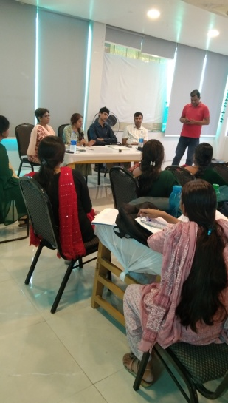
HWC ANM Training –District Jaipur-II

District Monitoring of training was done on July 28, 2023 to monitor HWC ANM training. Immediate feedback was provided to CMHO through a letter for gaps observed. Dr Suman Choudhary, Faculty HWC training and Ms Archana Saxena, training coordinator from SIHFW did this monitoring.
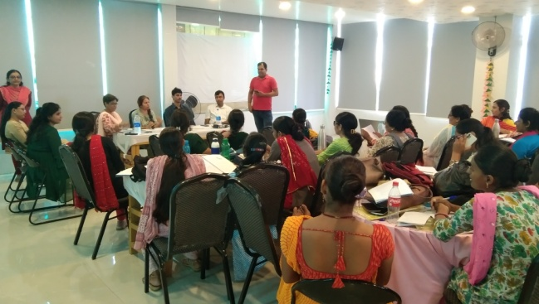

Dr Sunita Thakan, Faculty, Maternal Health, SIHFW did monitoring of Comprehensive Abortion Care (CAC) training batch at Government Medical College, Sikar
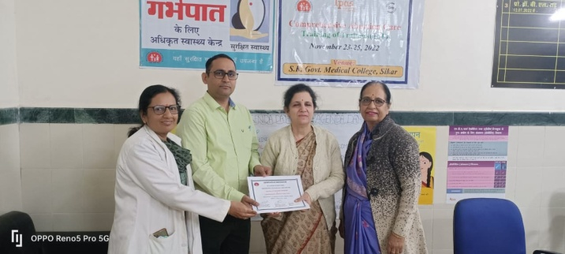

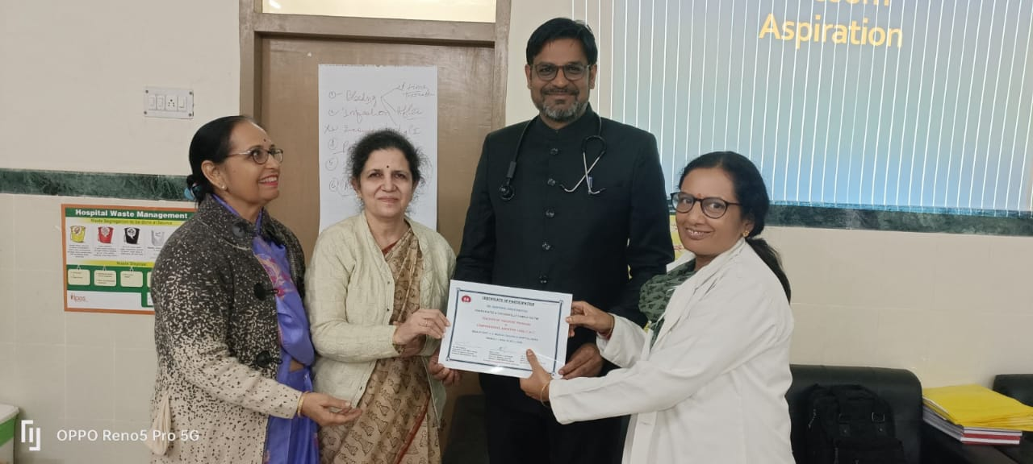

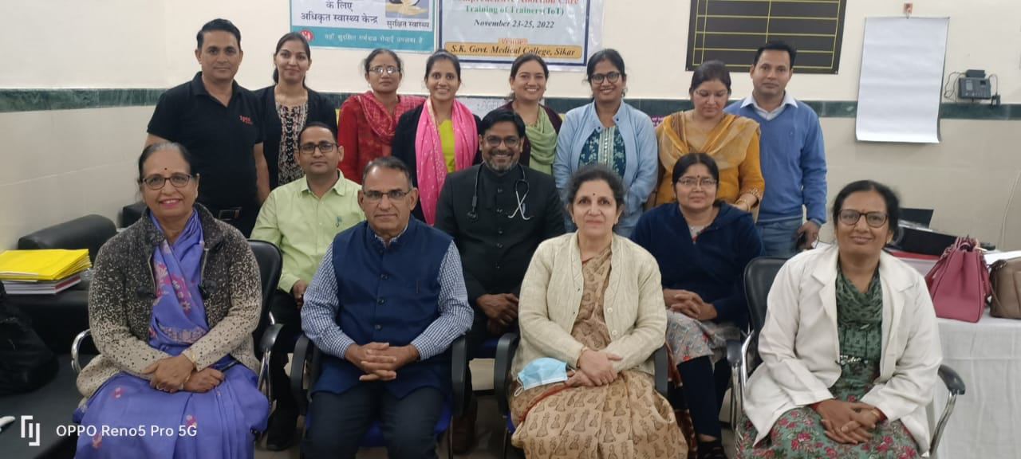

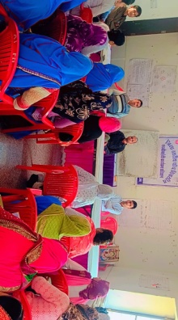
District Alwar Monitoring

Alwar district monitoring was done by Mr Sunil Patel, on Feb 21-22, 2023. Monitoring of CHO Induction training (15 days), ASHA training-Module 6&7 (5 days), HBYC training and SBA (21 days) was done at Alwar.

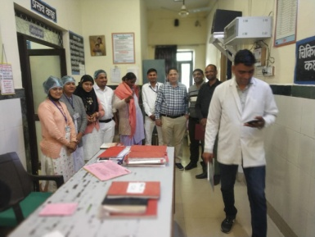

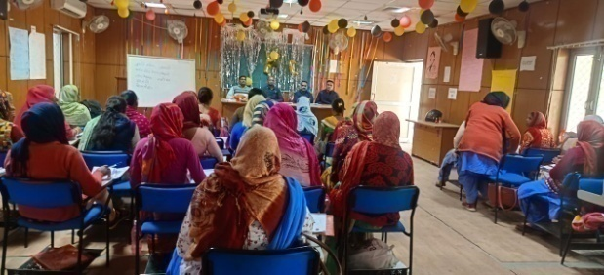

HBYC training at Alwar

21 days SBA training at Alwar
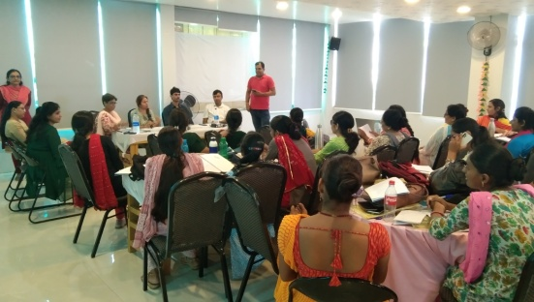

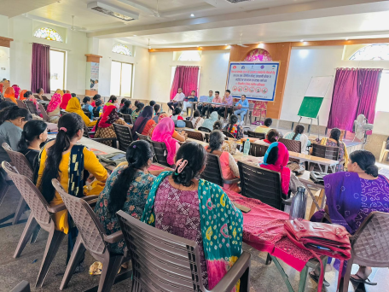
Picture Gallery of Field trainings
HWC-ANM training at Barmer

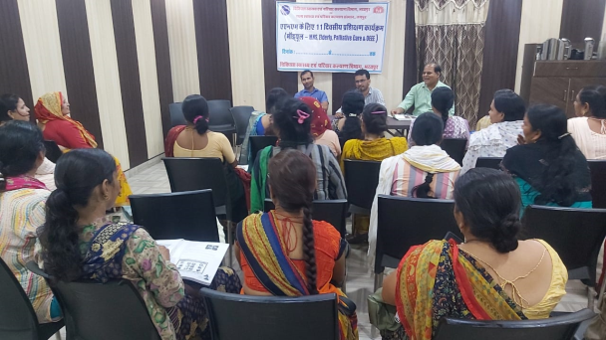

HWC-ANM training at Bharatpur

Health News
Ayushman Bharat Digital Mission (ABDM)

Government of India has launched Ayushman Bharat Digital Mission (ABDM) which aims to develop the backbone necessary to support the integrated digital health infrastructure of the country and create longitudinal Electronic Health Record (EHR) for the citizen. Union Health Ministry has notified Electronic Health Record (EHR) Standards to promote data standards which can facilitate interoperability of healthcare information across various health IT systems.
The National Health Authority (NHA) has issued several guidelines and notification to govern the conduct of digital health applications which are integrated with ABDM ecosystem. These include Health Data Management Policy, Data Privacy Policy &amp; ABDM Health Records (PHR) Mobile App Privacy Policy which sets out the minimum standards for data privacy and protection. NHA has also defined policies and procedures for authenticating digital healthcare applications which are part of ABDM ecosystem. Through a Sandbox environment, applications are validated and integrated within ABDM framework for facilitating wider use of digital health application across the country. Source:PIB: 1/8/2023

Update on treatment of Diabetes
As per Indian Council of Medical Research – India Diabetes (ICMR INDIAB) study published in 2023, the prevalence of diabetes is 10.1 crores. The details are available at the following link https://www.thelancet.com/journals/landia/article/PIIS2213-8587(23)00119-5/fulltext.
The Department of Health & Family Welfare, Government of India provides technical and financial support to the States/UTs under the National Programme for Prevention and Control of Non Communicable Diseases (NP-NCD), as part of National Health Mission (NHM), based on the proposals received from the States/UTs and subject to the resource envelope. Diabetes is an integral part of the programme. The programme focuses on strengthening infrastructure, human resource development, health promotion & awareness generation for prevention, early diagnosis, management and referral to an appropriate level of healthcare facility for treatment of the Non-Communicable Diseases (NCDs). Under NP-NCD, 724 District NCD Clinics, 210 District Cardiac Care Units, 326 District Day Care Centres and 6110 Community Health Centre NCD Clinics have been set up.
A population-based initiative for prevention, control and screening for common Non-Communicable Diseases (NCDs) i.e., diabetes, hypertension and common cancers has been rolled out in the country under NHM and also as a part of Comprehensive Primary Health Care. Under the initiative, persons more than 30 years of age are targeted for their screening for common NCDs. Screening of these common NCDs is an integral part of service delivery under Ayushman Bharat – Health and Wellness Centres which generates awareness on risk factors of NCDs including diabetes.
Preventive aspect of diabetes is strengthened under Comprehensive Primary Health Care through Ayushman Bharat Health Wellness Centre scheme, by promotion of wellness activities and targeted communication at the community level. In addition, NP-NCD gives financial support under NHM for awareness generation (IEC) activities for Diabetes to be undertaken by the States/UTs as per their Programme Implementation Plans (PIPs). Other initiatives for increasing public awareness about Diabetes and for promotion of healthy lifestyle include observation of World Diabetes Day and use of print, electronic and social media for continued community awareness.
Furthermore, healthy eating is promoted through FSSAI. Eat Right Initiative, Safe and Nutritious Food at Home and ‘Aaj se thoda kum’ awareness activities are also initiated. This initiative aims to promote both the demand for and the supply of safe and healthy food in a sustainable way. Fit India and Khleo India movements are implemented by Ministry of Youth Affairs and Sports, and various Yoga related activities are carried out by Ministry of AYUSH.
Diabetes patients are getting treatment at various health facilities in the health care delivery system including District Hospitals, Medical Colleges, Central Institutes like AIIMS, Central Government hospitals, and private sector hospitals. The treatment in Government Hospitals is either free or highly subsidized for the poor and needy. Source: PIB: 1/8/2023

Rajasthan Health News

Rajasthan will be made tuberculosis-free by 2025 with sustained efforts in the healthcare sector, while the disease has been eradicated in 29 village panchayats of the State, Chief Minister Ashok Gehlot said here on August 25, 2023. Rajasthan is the first State to declare the panchayat areas as tuberculosis-free.
Shri Gehlot laid the foundation stones for new medical institutions and flagged off 70 new ambulances at a programme here, while reiterating the State government’s commitment to provide health services in the remote areas. Rajasthan had 6% of the country’s tuberculosis patients and they were being identified for treatment at the village panchayat level, Mr. Gehlot said.
The Chief Minister said four districts of the State had been awarded silver medals and four bronze medals at the national level for excellent work in the tuberculosis eradication in 2022. While this indicated the State government’s achievement in dealing with the disease, continuous efforts were being made to make Rajasthan the leading State in all sectors, Mr. Gehlot said.
Rajasthan had emerged as a model State in health and education and was the first State to enact a law to give the right to health to the common people, Mr. Gehlot said, adding that the model was being praised all over the country. Good human resource could develop from a robust health and education infrastructure, he said. Source: DIPR 25.8.2023
We solicit your feedback:
Editing and Compilation by: Archana Saxena, RO; IT support: Mohit Dhonkeriya;
Mentored by: Dr Sunita Thakan, Faculty-Gyne
State Institute of Health & Family Welfare
Jhalana Institutional Area, South of Doordarshan Kendra Jaipur (Raj)
Phone-2706496, 2701938, Fax- 2706534
E-mail:-sihfwraj@ymail.com; Website: www.sihfwrajasthan.com

